CWBI Forecasting Application Proposal

VIncent Jullien / Mike Lane - Emory Continuing Education

Data Analytics for Social Good

2/12/2018

As a follow-up to our efforts last year which resulted in an Excel tool forecasting improvement to the Child Well Being Index (CWBI) on a County-wide basis for Metro Atlanta, United Ways of Greater Atlanta (UWGA) has asked us to come up with an evolution.

Specifically UWGA would like us to develop a solution that will allow a user to select new specific values for several of the 14 indicators, and forecast the values of the remaining indicators in order to reach a specified value of CWBI. This requirement implies the use of a Optimisation and Equation Solving tool which potentially has to address 13 out of the 14 indicators as part of the forecasted scenario. This vastly exceeds the capabilities of the Solver tool in Excel, and for that reason, we would like to propose to use the R programming language, along with the RStudio Integrated Development Environment (IDE), and the R Shiny web visualization package.

1. RStudio and R Shiny pricing

NOTE: We can run all the proposed applications using free (AGPL v3) Licenses on one or several standalone laptops for UWGA’s internal use. Fees will only come into play if UWGA decides to publish the application on a server for wide-spread internal use or for use by the general public.

RStudio is the R Language IDE and is available free of charge under the terms of an AGPL v3 license. This free license is perfectly sufficient for our needs, from a technical standpoint. A commercial license with professional maintenance (8 Hours Response during Business Hours EST) can be purchased for $995 a year (list prices). (<https://www.rstudio.com/products/rstudio/#Desktop>)

R Shiny is a web-based User Interface package for RStudio. The R Shiny extension is available as part of the RStudio Package at no additional charge. It allows an operator to use a web page to enter data into an R program (i.e. using a slider to change the value of an index) and visualise the output of the R program (i.e. a bar graph of the Actual and Forecasted values for the Child, Family, and Community indexes, along the the CWBI) on the same web page.

That Web page is residing on the same computer where RStudio is running, but can be published on a web server on the UWGA Intranet or in the cloud using a site called Shinyapps.io. Pricing (list) for Shilyapps.io is as follows (http://www.shinyapps.io/#pricing):

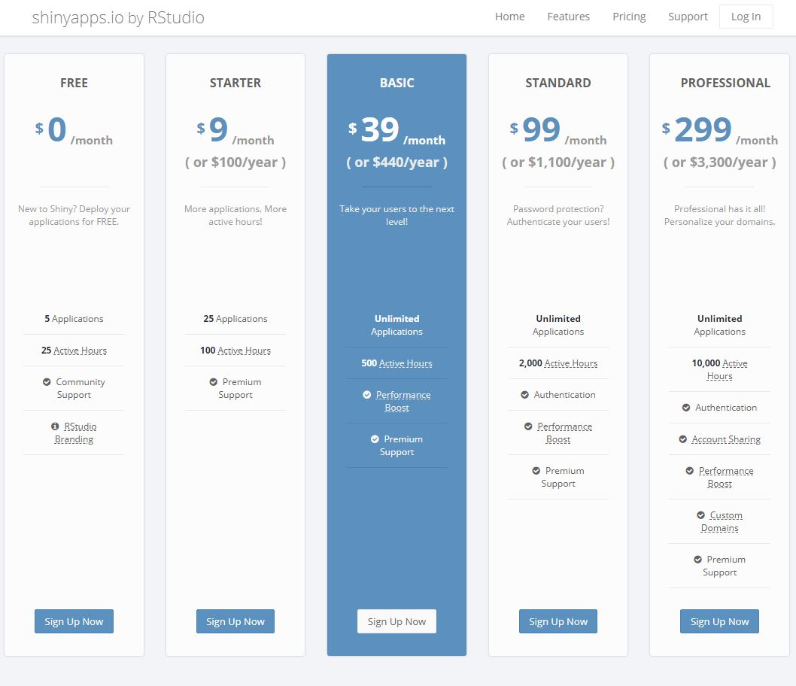

Depending on UWGA plans for the application, The Starter plan (100 hours a month) or Basic plan (500 hours a month) should be sufficient.

Shinyapps.io will allow the inclusion of the R program User Interface in the current United Ways public when site and as such represents a significant improvement over the self contained RStudio / R Shiny setup running on one or more individual laptops.

1. Proposed Versions of the New R Application.
   1. V1 - Compute a new Metro Atlanta CWBI value based on Slider Inputs for all 14 Indicators - Available end of February

In this version, 14 sliders (one per indicator) will be provided, each set at the current, actual average value of that indicator for Metro Atlanta. The operator can then slide all or any of the indicators all the way to the upper boundary and watch the evolution of the 4 Indexes via a bar graph or other visualization on the same web-page.

The release of this version will allow us to start refining the visualization requirements with UWGA, as well as start addressing which solution to use to deploy the application.

We also assume we will have access to all the boundaries for the 14 indicators, as defined by UWGA.

* 1. V2 - Forecast new values for a subset of Indicators based on a desired New Metro Atlanta CWBI value, and on Selected new values set by an operator for the other indicators - Available End of March

In this version, the operator will select (direct typing or slider) the desired target value for the Metro Atlanta CWBI. The operator will also select new desired values for some of the 14 indicators, and click on a “Execute” button. The resulting forecast for the other indicators (not touched by the Operator) will be displayed.

* 1. V3 - Similar to V2 but county-based: for a given county, forecast new values for a subset of Indicators based on a desired new County CWBI value, and on Selected new values set by an operator for the other indicators - Available End of April

Similar to V2, but with the additional choice of Metro Atlanta or a specific county.

These represent high level ideas, and we remain open to further discussion. We already have build a sizeable portion of the BCBWI computation algorithm in R, and are evaluating several different Solver / Optimizer packages for possible use.